CAREER EDUCATION CENTER
MEDICAL ASSISTING WORKBOOK

Name |

Chapter 5; THE PHYSICAL EXAM
Objective: To know, understand and demonstrate the procedures commonly used in a physical exam including:
- Preparing the exam room & the patient
- Measuring height and weight
- Body mechanics
- Positioning and draping
- Patient assessment; inspection, palpation, percussion, auscultation
- Assisting the physician

- Have you ever had, or been with someone who had, a physical exam?
- Was it for work, school, sports or -?
- What do you remember about it the most?

- The physical exam consists of 3 parts: (page 173)
Preparing the Exam Room (Page 176)
- Label the tray set-up:
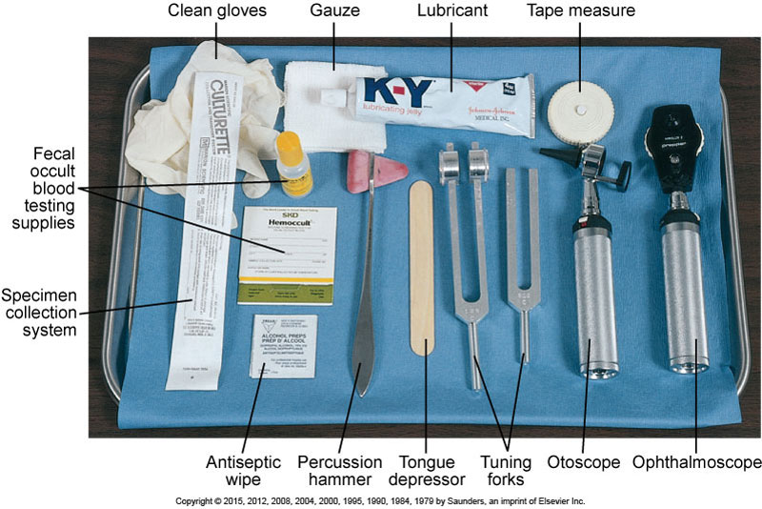

Lab: Identify the instruments in the lab:
Procedure; Passing instruments
Pass a tongue depressor signed that you did this correctly

Pass scissors signed that you did this correctly

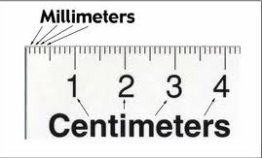
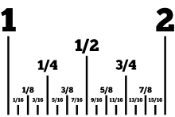
Measuring

The abbreviation for inches is _____________
The abbreviation for centimeters is ________________
½ a centimeter is written as ________________
Using a tape measure, measure your partner to the nearest 1/4 inch & in centimeters:
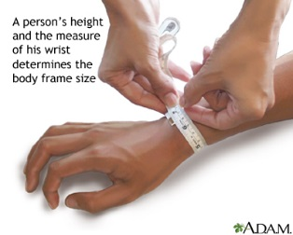
Ankle wrist
Inches ______________ Inches ______________ centimeters__________ centimeters__________

MENSURATION or Measuring is one of the most important tasks of the medical assistant
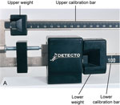
Measuring weight

- Identify the weights below:

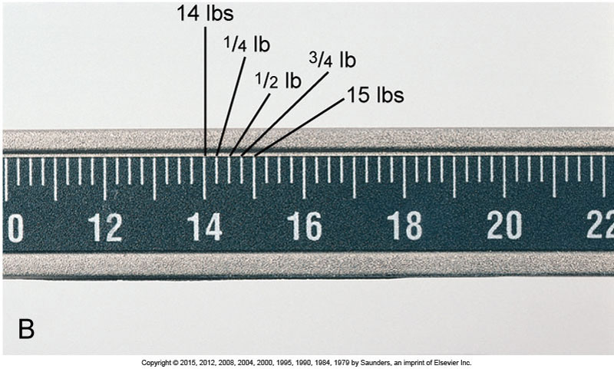
LAB; Read the weight scales set in the lab:

- Write the weight that the scales below are pointing to:
_______________________________________________________________________________
Examination can be by: palpation, auscultation, inspection or percussion
Can you name which is happening here?
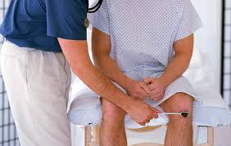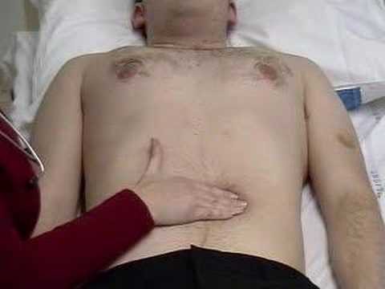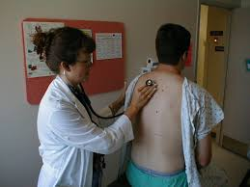
A__________________ B_______________ C_____________ D _____________

HEIGHT
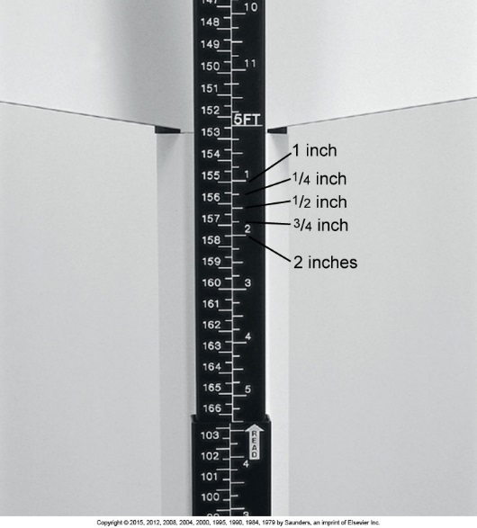
B. Reading Height Measurements
The following diagram is an illustration of a portion of the calibration rod of an upright balance beam scale. In the spaces provided, indicate the height measurement in feet and inches indicated on the calibration rod.
Read the Height Scales set in the lab

Record your partner’s height in inches
- - in centimeters

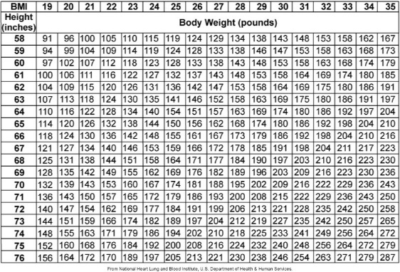
Body Mass Index
BMI is used to calculate correct amount (dose) of medication.
The formula for BMI =
Lbs x 703 . ÷ ins ÷ ins

Interpretation;
≤ 18.5 underweight,
≥ 30 overweight

Calculate the Body Mass Index on the following
 | Weight in lbs. | Height | BMI | Interpretation
 | 146 | 6 5”
 | 175 | 6 6”

HEIGHT: Feet & Inches:
- Since there are 12 inches in one foot, how many feet are in:
- 48 ins 60ins 72ins
- Put into feet and inches:
48 | 60 | 72
49 | 61 | 73
51 | 65 | 75
57 ½ | 67 ½ | 77 ¼

Measure your partners in Feet and inches to the nearest ½ inch.
  - _________________________ 2, _________________________________

Pass the feet and inches lab test: signed by

Positions: Name the positions and one use for each
Lithotomy prone supine Sims
Semi-fowlers knee-chest fetal dorsal recumbent

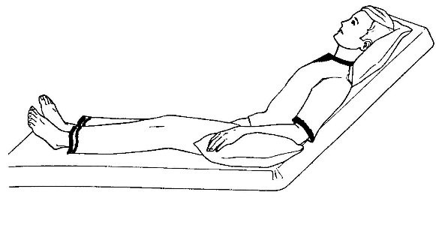
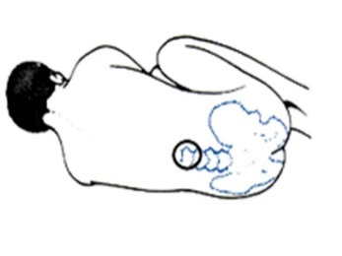
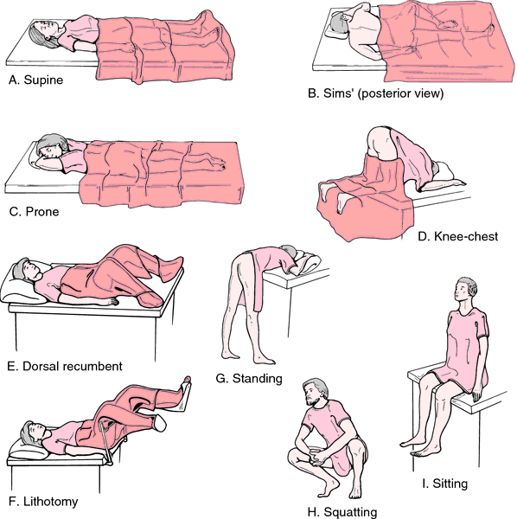
In which position would you place these patients?
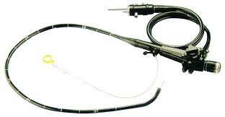flex sig

