*Sterilization*

*Chapter 3*

*Temperature*

*Chapter 4*

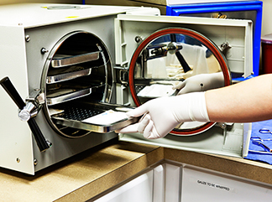

Name _______________________________________________

Clinical Medical Assisting workbook:

Chapters 3 & 4

Chapter 3: Sterilization and Disinfection

1. Match the terms:
   1. Sanitation
   2. Decontamination
   3. Detergent
   4. Disinfectant
   5. Spore
   6. Sterilize
2. soap
3. a hard, thick walled capsule around
4. washing
5. removal or destroying of pathogens
6. a chemical used to destroy pathogens but not spores
7. use a sterilizer or autoclave

Hazardous Chemicals

1. How should you dispose of the disinfectant “Cidex” in Fig. 3-1?
2. The MSDS sheet shown in Fig. 3-2 is about
3. What would you do if it splashed into your eye?

DISINFECTIONS

|  |  |  |
| --- | --- | --- |
| **Level of disinfectant** | **What it kills** | **Example** |
| High level |  |  |
| Intermediate level |  |  |
| Low level |  |  |

1. What would you use to disinfect: From table 3-1

|  |  |
| --- | --- |
| Sigmoidoscopes |  |
| Stethoscopes |  |
| Tables and walls |  |
| Blood spills |  |

Storing Disinfectants

1. Shelf life is how long it is good for on the shelf before being mixed. It is the
2. Use life is how long it is good for after being
3. In Fig 3-8 is the autoclave tape on top before or after sterilizing?

*Procedure 3-3 Wrapping Instruments-*

*What would you write on the package?*

*Signed that you did this:*

**From table 3-2, complete the Autoclave Log:**

|  |  |  |  |  |  |  |
| --- | --- | --- | --- | --- | --- | --- |
| AUTOCLAVE LOG | | | | | | |
| Date/Time | Description of the Load | Cycle Time  (min) | Temperature  (°F) | Indicator*  (+/-) | Initials | Comments |
| 7/52/17  4:00 PM | Surgical Instruments | 20 | 250 | _ | KY |  |
| 7/26/17  3:00 PM | MOS tray setups | 30 | 250 | _ | KY |  |
|  | Rubber tubing |  |  |  |  |  |
|  | Liquids |  |  |  |  |  |
|  | Open glass container |  |  |  |  |  |

**Sterilization**

For each of the following situations involving sterilization, write *C* if it is correct and *I* if it is incorrect

1. The MA opens a hemostat before placing it in a sterilization pouch.
2. Tap water is used to fill the water reservoir.
3. When loading the autoclave, the MA places glass jars in an upright position.
4. The MA places four sterilization pouches on top of each other in the autoclave.
5. The MA places small packs to be sterilized approximately 1 to 3 inches apart in the autoclave.
6. Spore strips are placed in the autoclave where steam would penetrate them most easily.
7. The MA begins timing the load in the autoclave after the proper temperature of 205° F has been reached.
8. The MA removes the load from the autoclave while it is still wet.
9. The MA notices a tear in one of the wrappers while removing articles from the autoclave. She rewraps and resterilizes the article.
10. The MA notices that a sterilized wrapped article has unwrapped. She re-apes the pack and places it back on the storage shelf.

**TEMPERATURE**

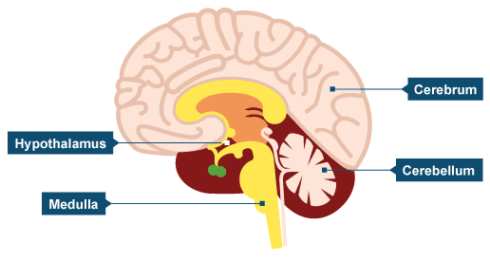The part of the brain that regulates body temperature is the

_____________________________________________

Many factors can affect the temperature reading.

Mark if the following would make it go up or down:

|  |  |  |
| --- | --- | --- |
| Emotion  Q:\140066.enu\MEDIA\CAGCAT10\j0302953.jpg | C:\Users\richard brammer\Pictures\download preg.jpgpregnancy | Young ageC:\Users\richard brammer\AppData\Local\Microsoft\Windows\Temporary Internet Files\Content.IE5\3YMF1OQ8\MC900285676[1].wmf |
| Exercise  C:\Users\richard brammer\AppData\Local\Microsoft\Windows\Temporary Internet Files\Content.IE5\XIXUKO0W\MC900389120[1].wmf | Cold drinksC:\Users\richard brammer\AppData\Local\Microsoft\Windows\Temporary Internet Files\Content.IE5\NWBL5703\MC900413606[1].wmf | Crying C:\Users\richard brammer\AppData\Local\Microsoft\Windows\Temporary Internet Files\Content.IE5\NWBL5703\MC900445490[1].wmf |
| C:\Users\richard brammer\AppData\Local\Microsoft\Windows\Temporary Internet Files\Content.IE5\ZJQAFJ1W\MC900445558[1].wmfOld age | C:\Users\richard brammer\AppData\Local\Microsoft\Windows\Temporary Internet Files\Content.IE5\ZJQAFJ1W\MC900128144[1].wmfNight    **(Diurnal variation)** | InfectionC:\Users\richard brammer\AppData\Local\Microsoft\Windows\Temporary Internet Files\Content.IE5\XIXUKO0W\MC900440672[1].png |

THE AVERAGE ADULT TEMPERATURE RANGE IS _______________________________________

Temperature is usually measured in Fahrenheit. E.g.,. 98.6 ‘ F

If the thermometer switches to Celsius, (E.g. “37 C”) then press the button until it switches back to “F”

**Temperature Sites**

Label the picture to show where you could take a temperature.

C:\Users\richard brammer\AppData\Local\Microsoft\Windows\Temporary Internet Files\Content.IE5\3YMF1OQ8\MC900285676[1].wmfUse abbreviations for each site e.g. T: 98.6 (® ear).

* O = mouth
* AS or AD= left or right ear or tympanic
* R = rectum,
* TA = forehead or temporal artery
* Ax= axilla,

Charting: Complete the following chart notes E.g. T: 98.6 ( Lt. ear), T: 98.6 (Ax).

-an oral temperature of 98.6

Date

-an temporal artery temperature of 98.6

Date

-a tympanic temperature 98.6 in the left ear

Date

-a tympanic temperature 98.6 in the right ear

Date

-an axillary temperature of 98.6 in the right armpit

Date

-a rectal temperature of 98.6

temperature

Date

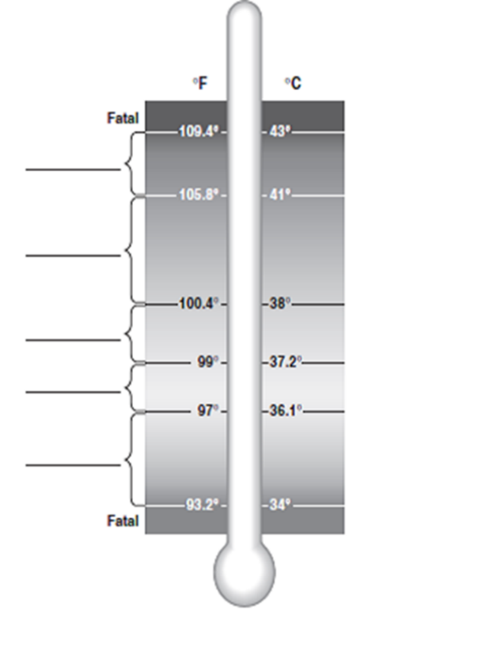Label the thermometer

From page 119

Heat is transferred by:

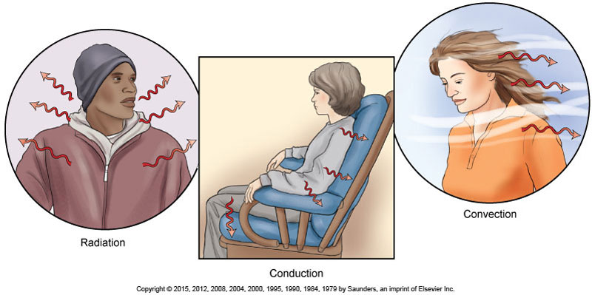

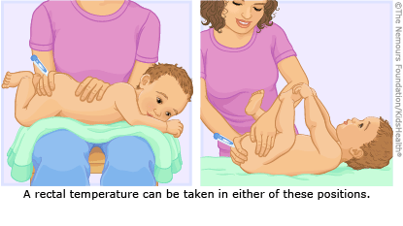Rectal Temperature:

Procedure 4-3 Take a Rectal Temperature

Signed that you did this correctly:

Tympanic Temperature: Read “Guidelines to using a Tympanic thermometer” on page 127 and page 134

You dispose of the cover in the _______________________________________

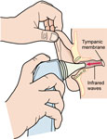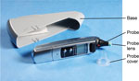

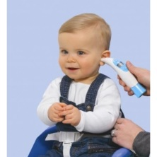Which way would you pull the ear back on:

A CHILD An ADULT

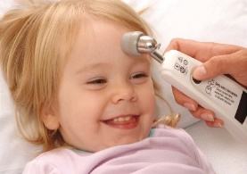

Temporal Artery Temperature

Review the directions on page 134

Oral Thermometer

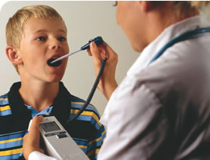Replace the probe after use to turn off and save the battery

Be careful you don’t poke the frenula lingua under the tongue

**Procedure: Measure temperatures.**

Include the CC. (chief compliant)

|  |  |  |  |  |
| --- | --- | --- | --- | --- |
|  |  | | | |
|  |  | | | |
|  | | |  |  |  |

Types of Fevers: Continuous, Intermittent, Remittent,

  

TEST Word Bank: Febrile, temporal artery thermometer, afebrile, antipyretic, hypothalamus, malaise, pyrogen, 100.4F

|  |  |
| --- | --- |
| 1. A substance like Tylenol that reduces fever is an |  |
| 1. A fever is over - |  |
| 1. If someone has a fever he is said to be |  |
| 1. If he has NO fever he is said to be |  |
| 1. A substance that produces fever is a |  |
| 1. The part of brain that controls temperature called |  |
| 1. A vague sense of body discomfort or tiredness is |  |
| 1. A thermometer that reads the forehead is a |  |

Record these temperatures:

Temperature 100.5 F in the right ear, 100 F taken in the mouth, 101 F taken in the forehead ,101F rectally.

________________________________________________________________________________________

Where would you take the temperature on these people?

  